**How You Like That**

POSE 1 00:00:01:07

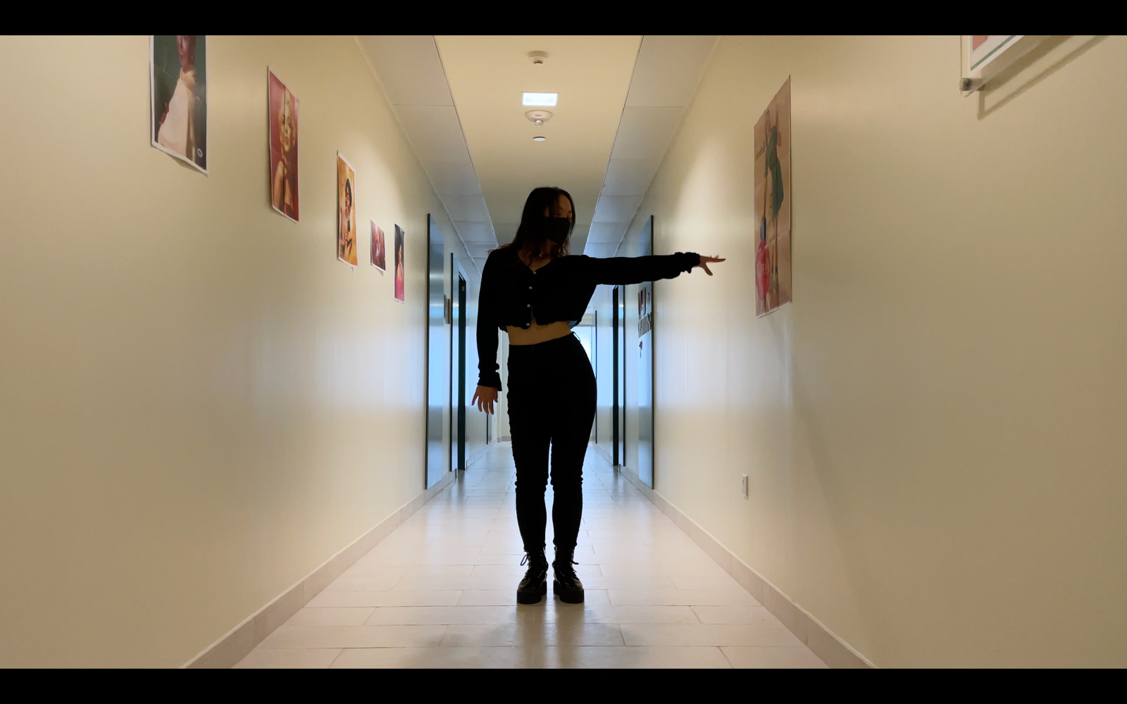

POSE 2 00:00:03:16

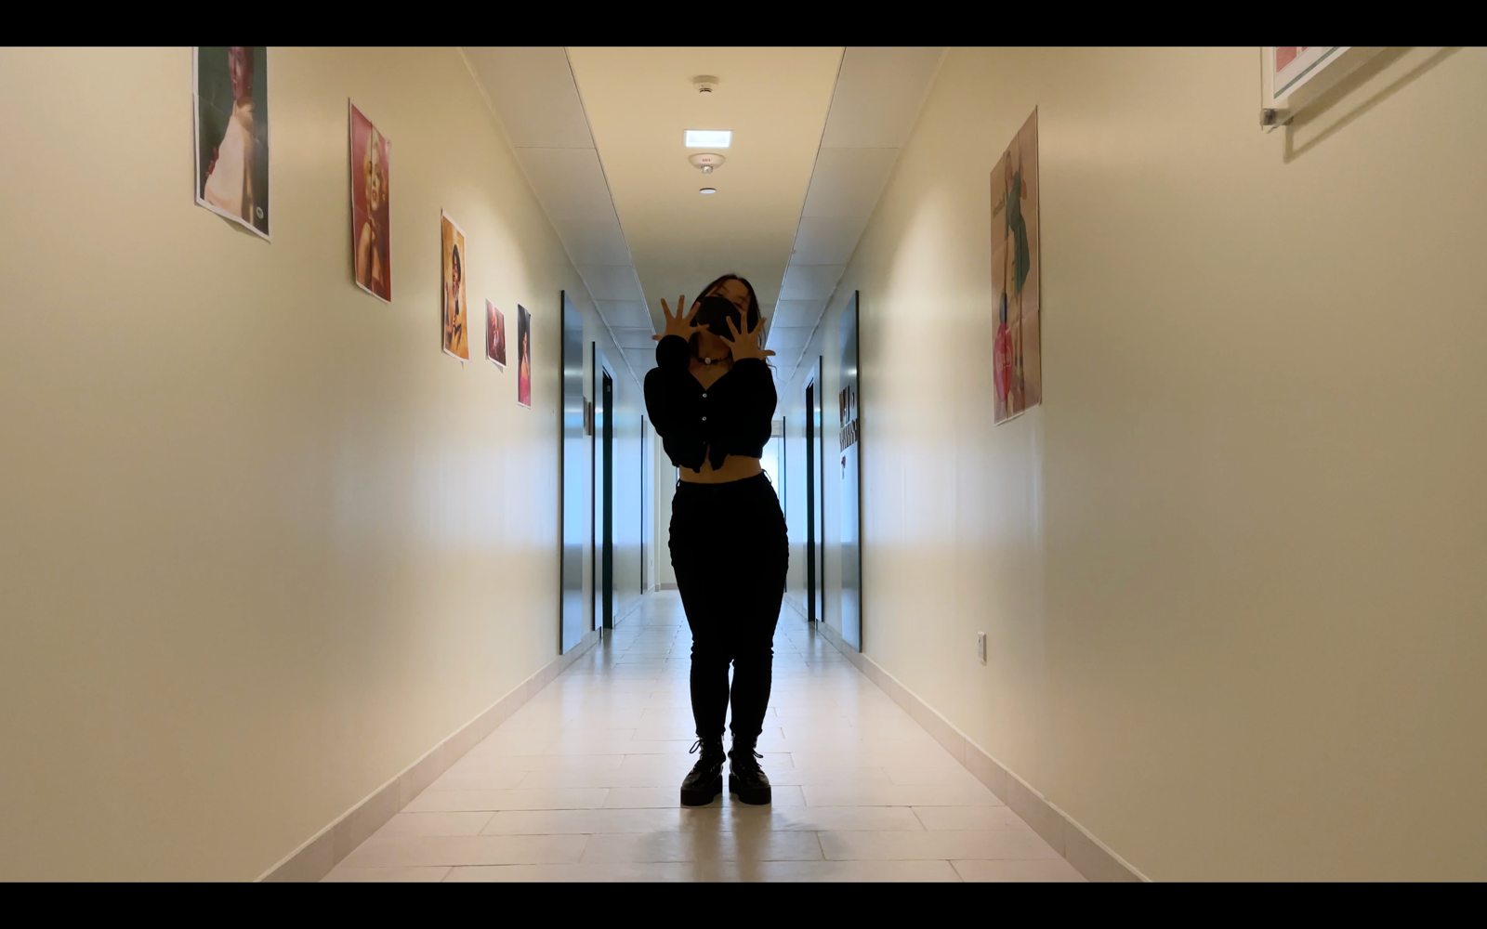

POSE 3 00:00:07:15

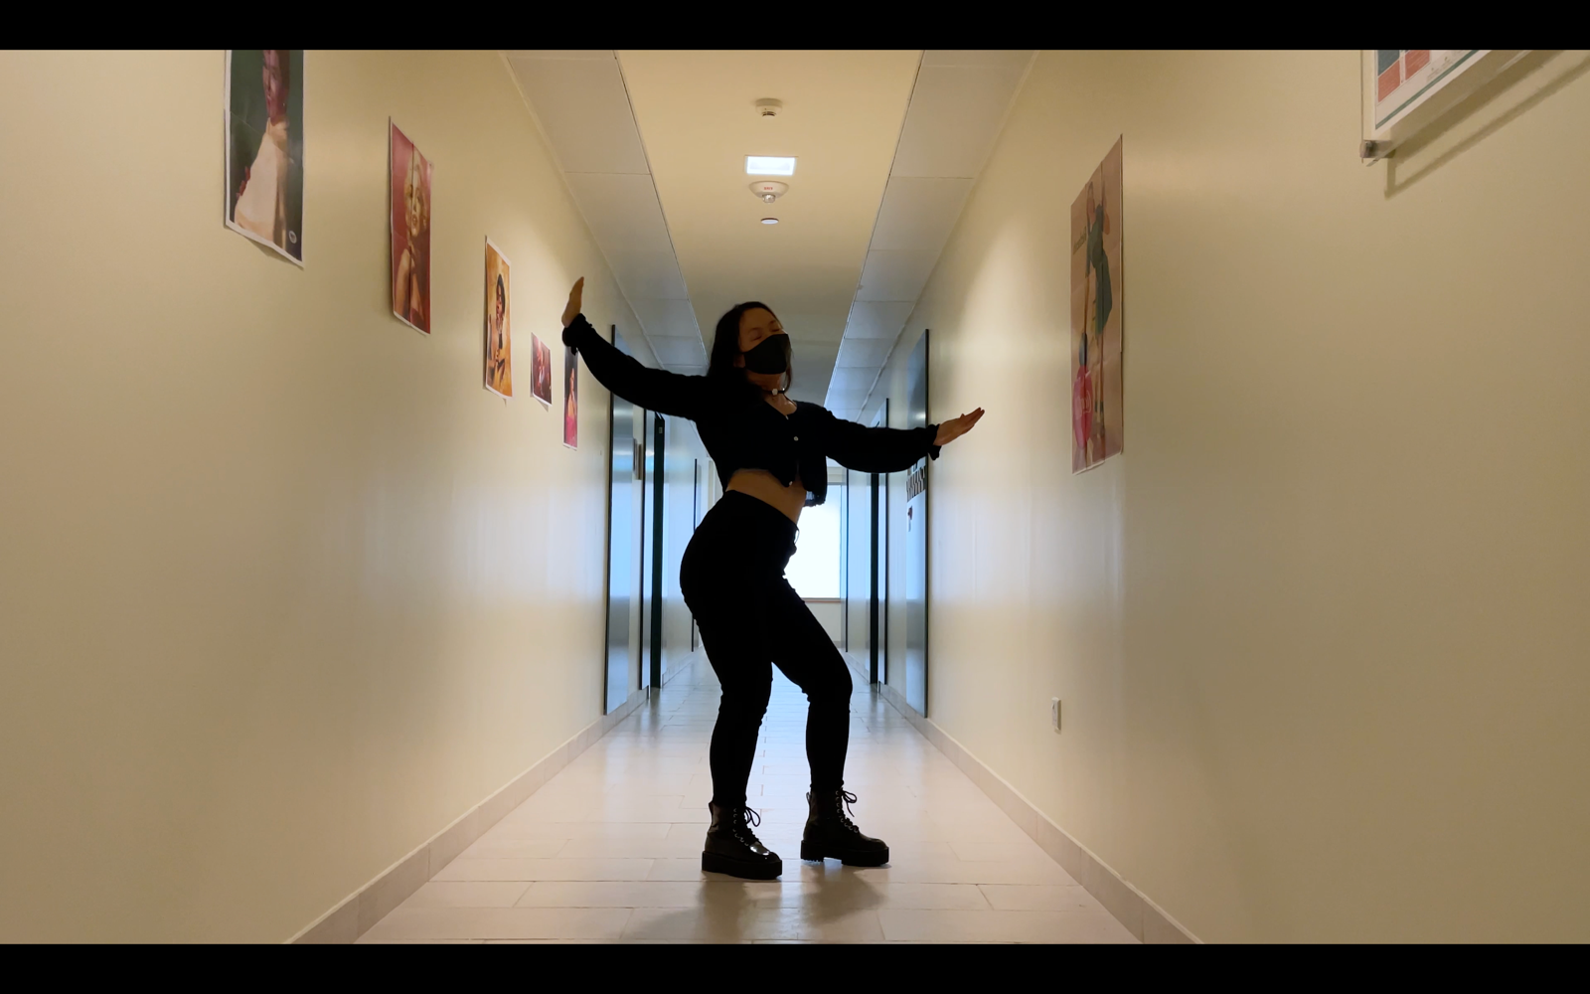

POSE 4 00:00:08:10 & 00:00:09:03

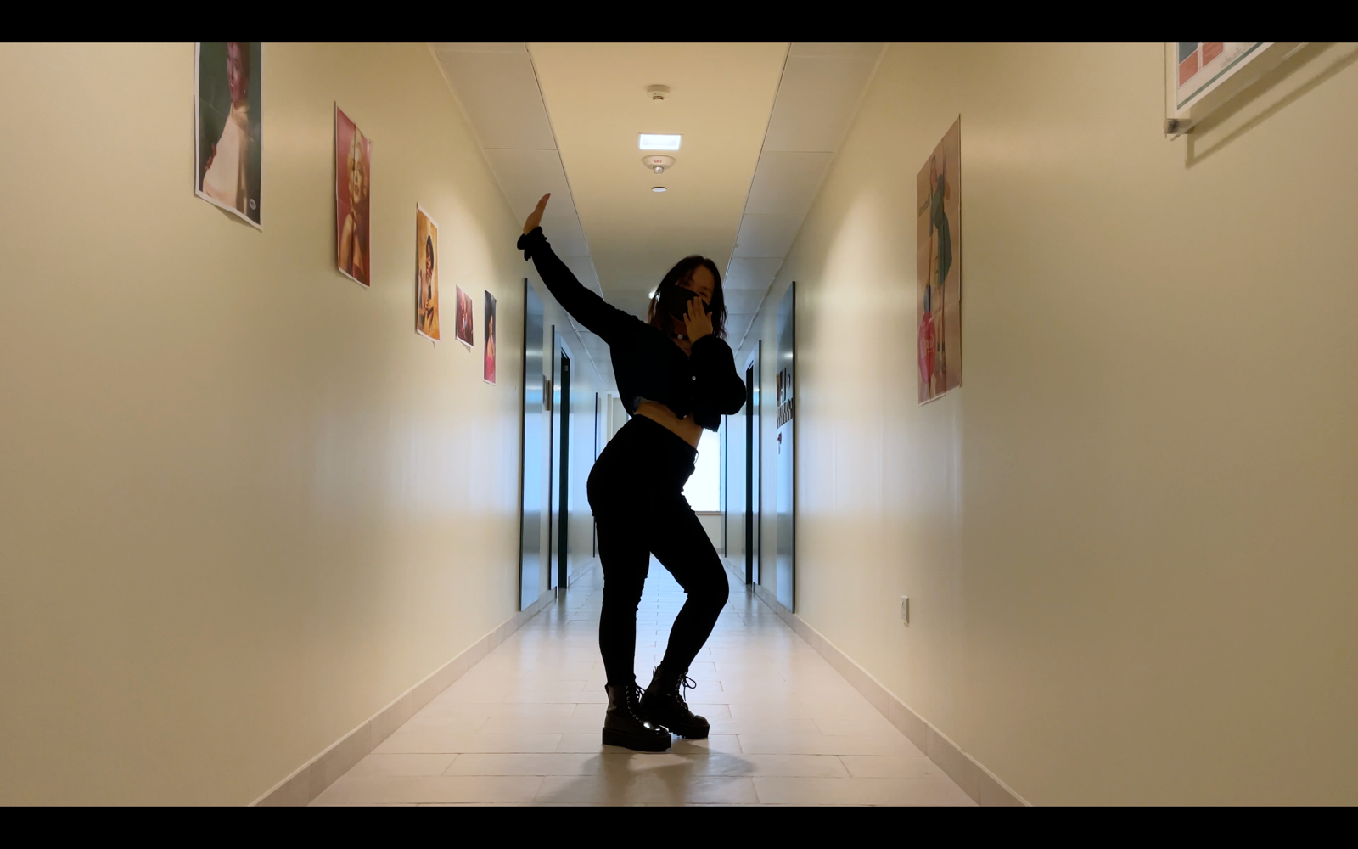

POSE 5 00:00:14:02

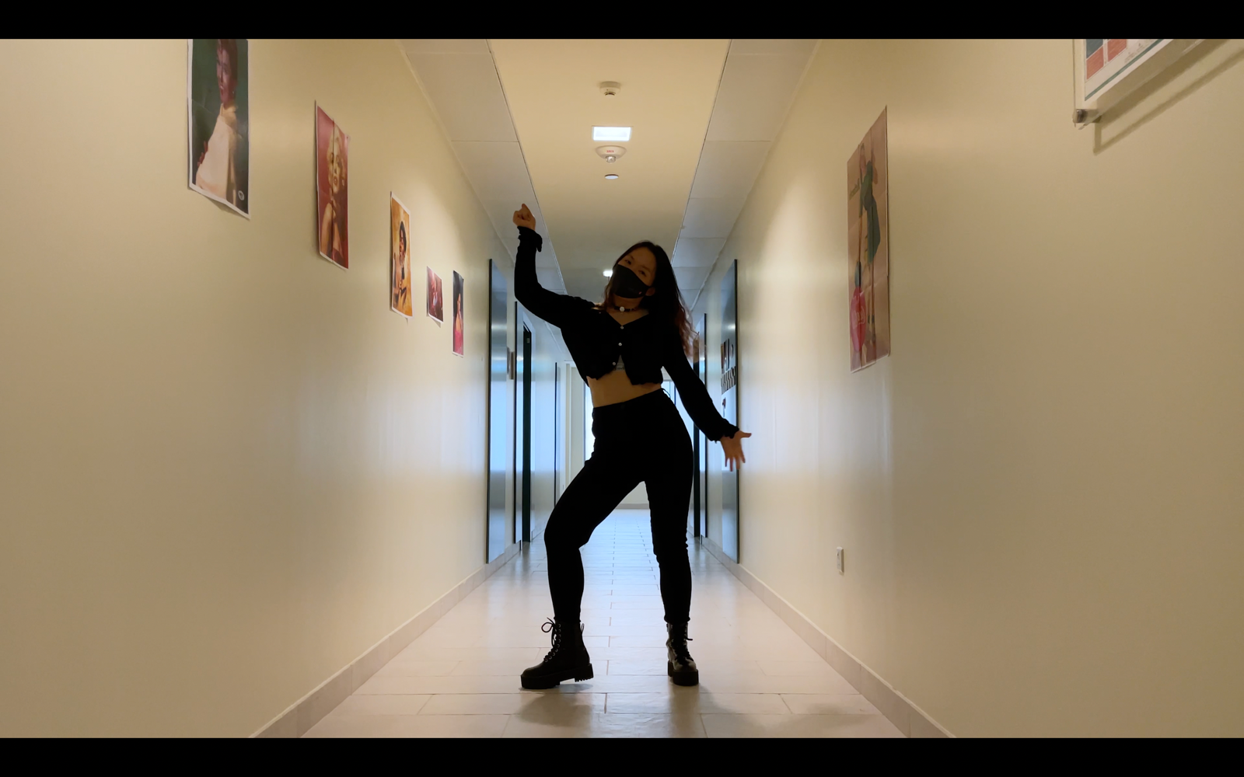

POSE 6 00:00:17:19

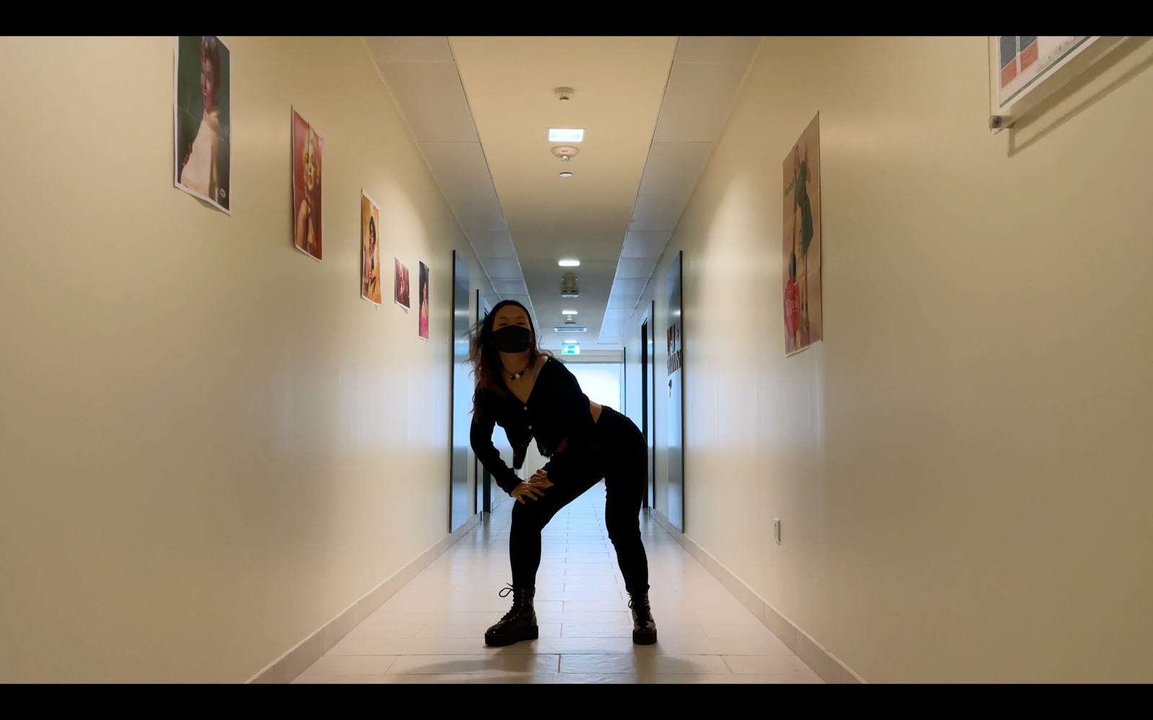

POSE 7 00:00:19:05

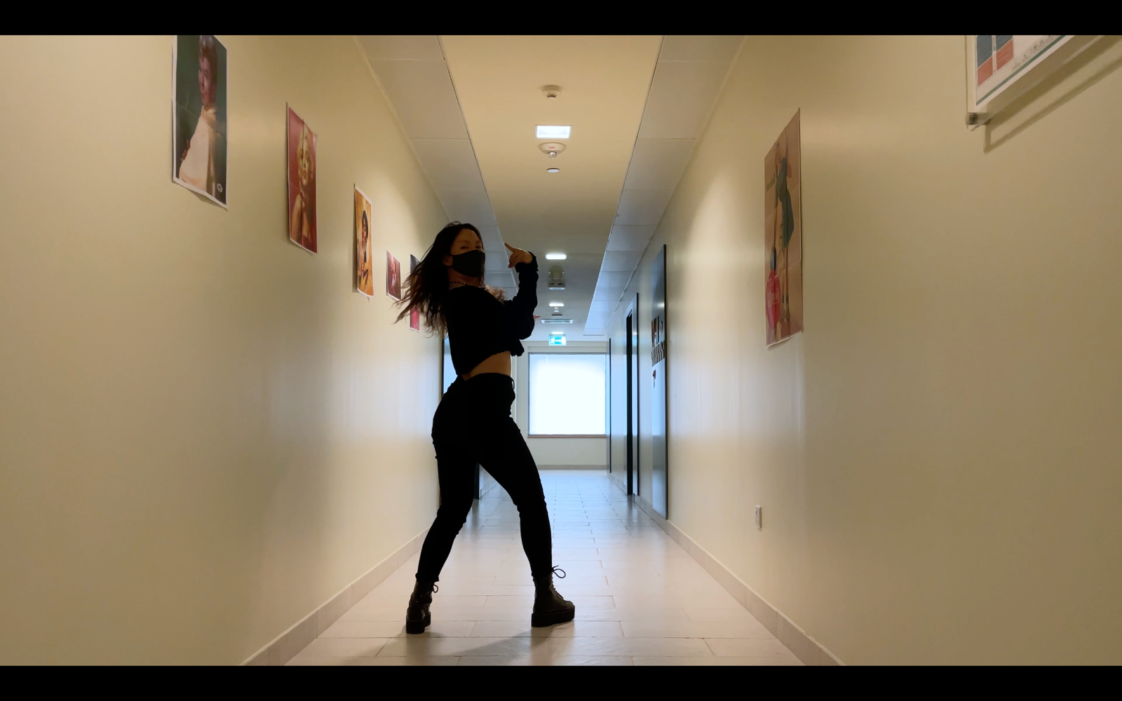

POSE 8 00:00:22:19

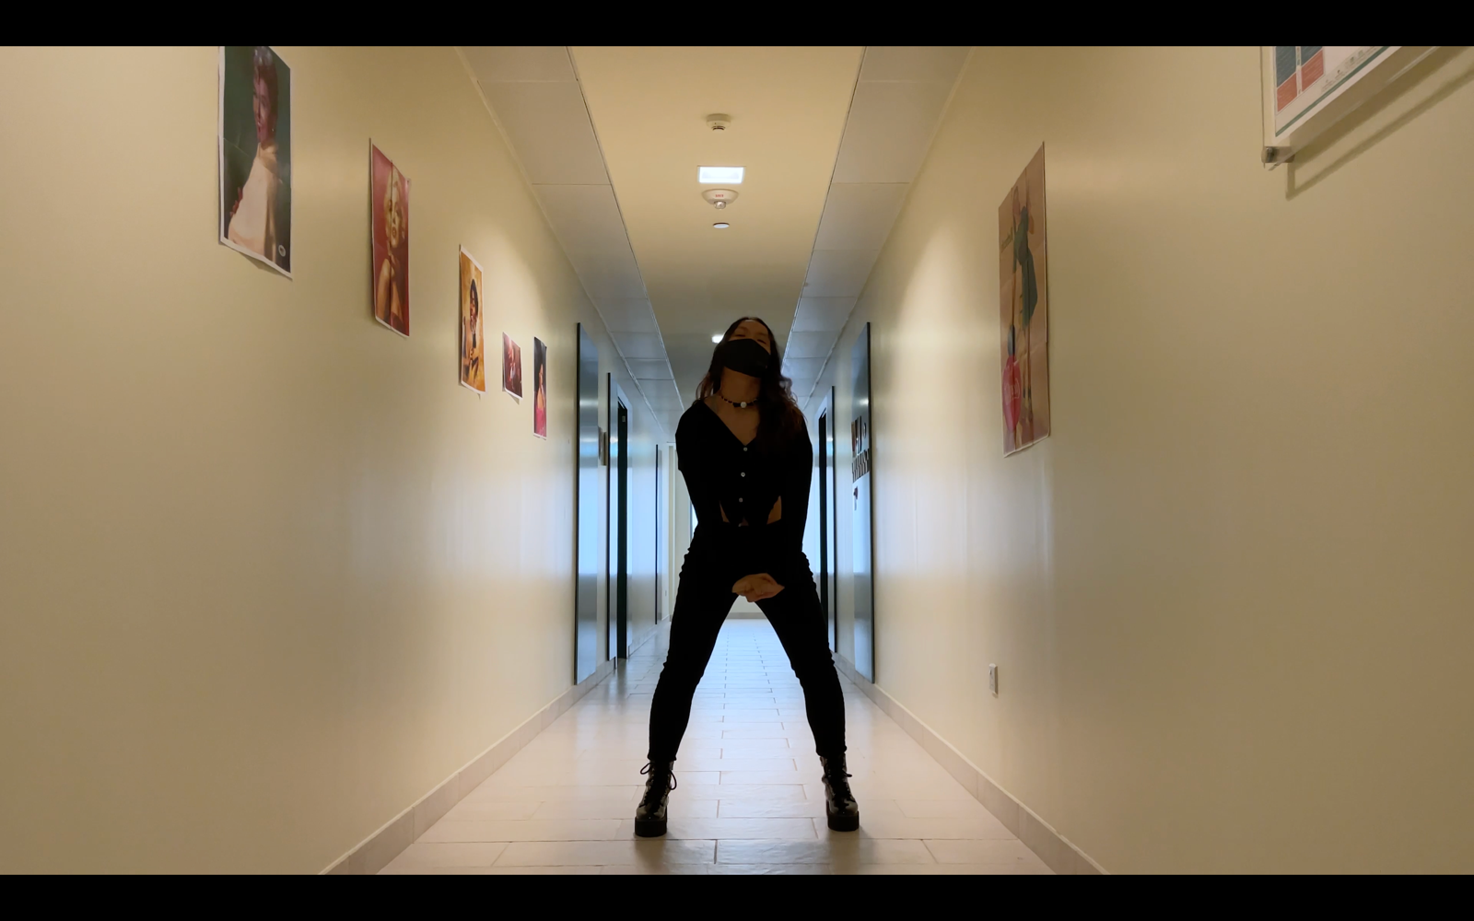

POSE 9 00:00:23:13

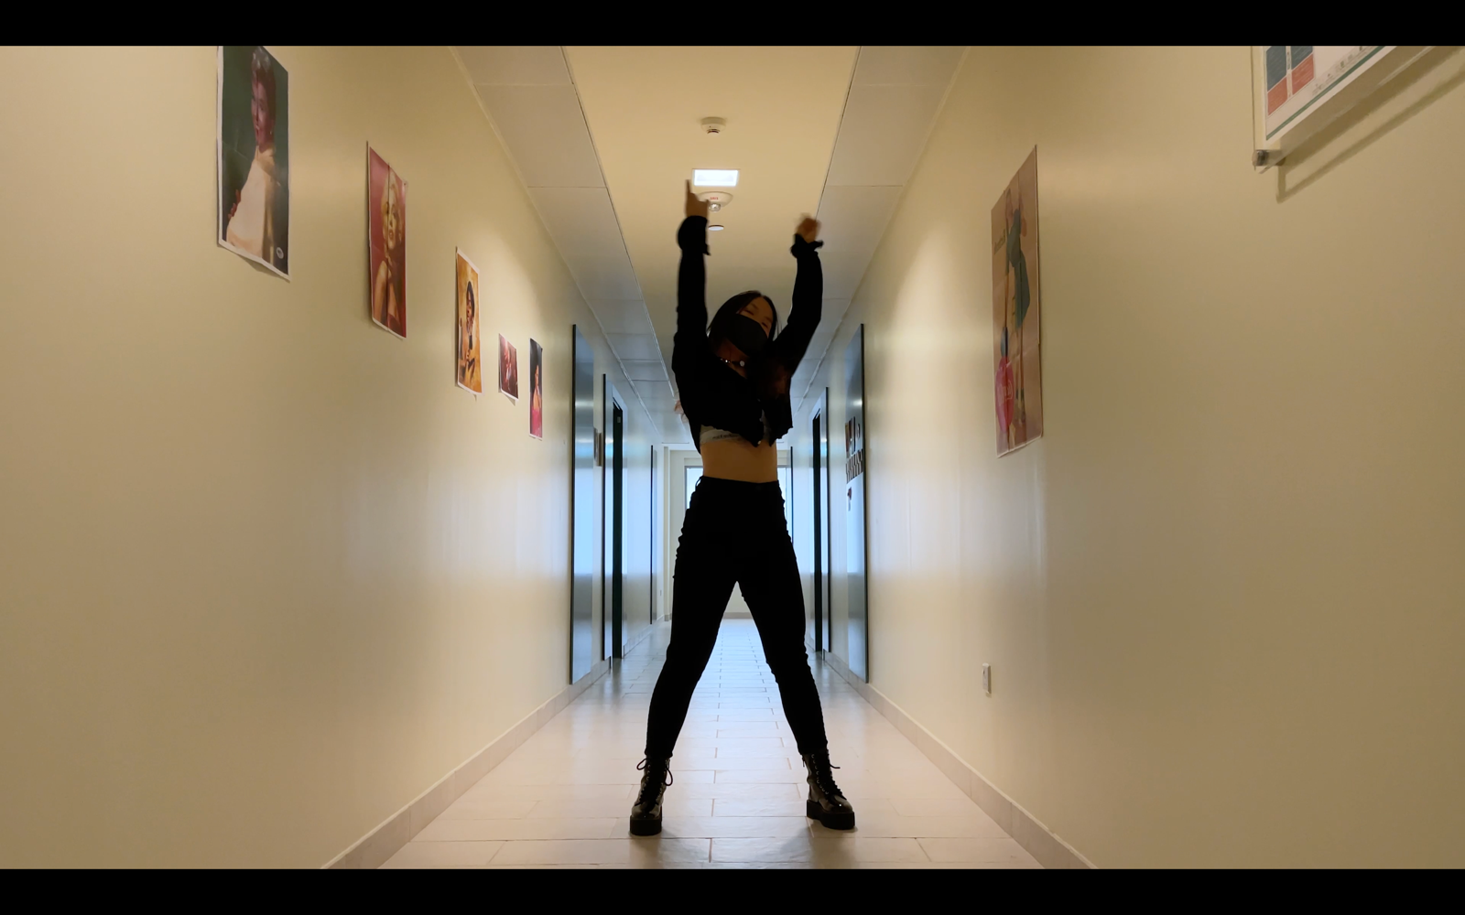

POSE 10 00:00:25:26

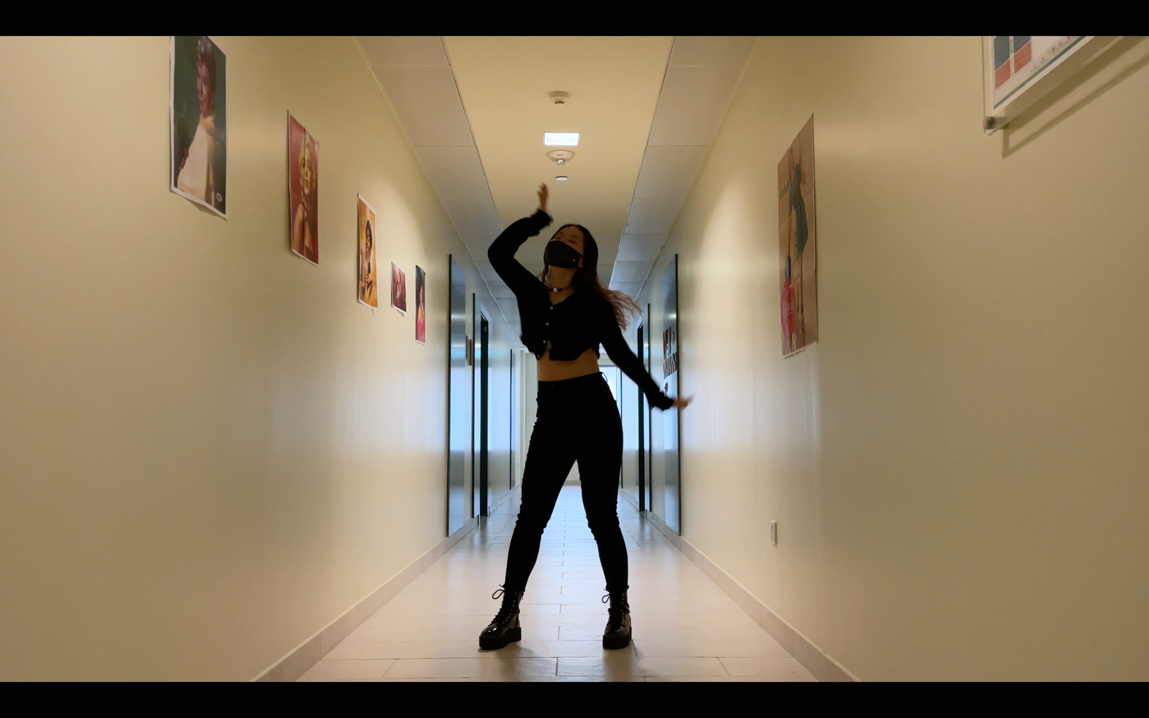

POSE 11 00:00:28:12

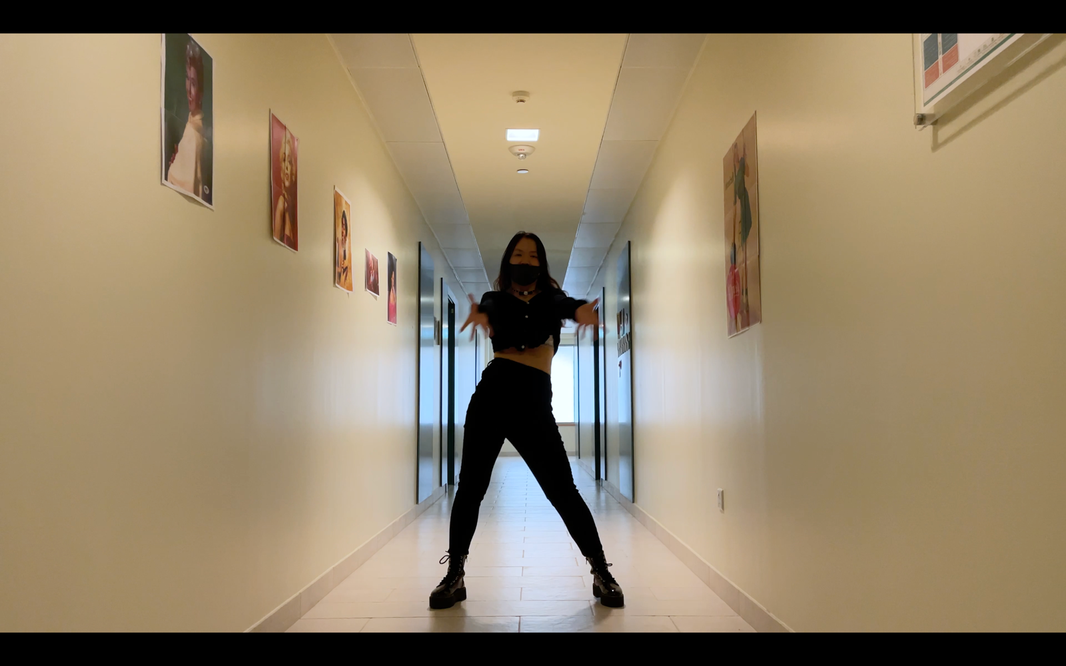

POSE 12 00:00:30:10 & 00:00:33:02 & 00:00:34:16

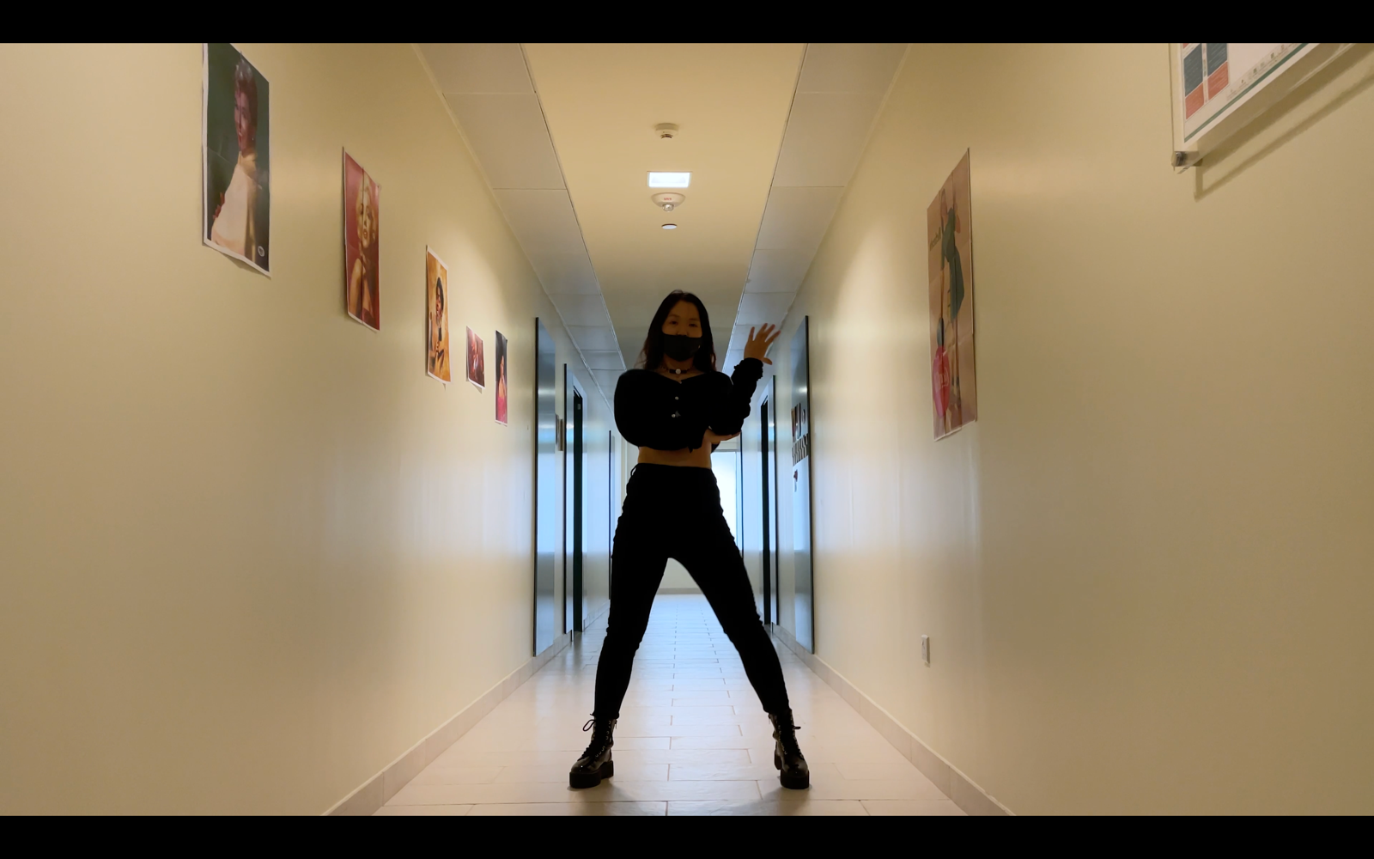

POSE 13 00:00:32:01 & 00:00:33:23

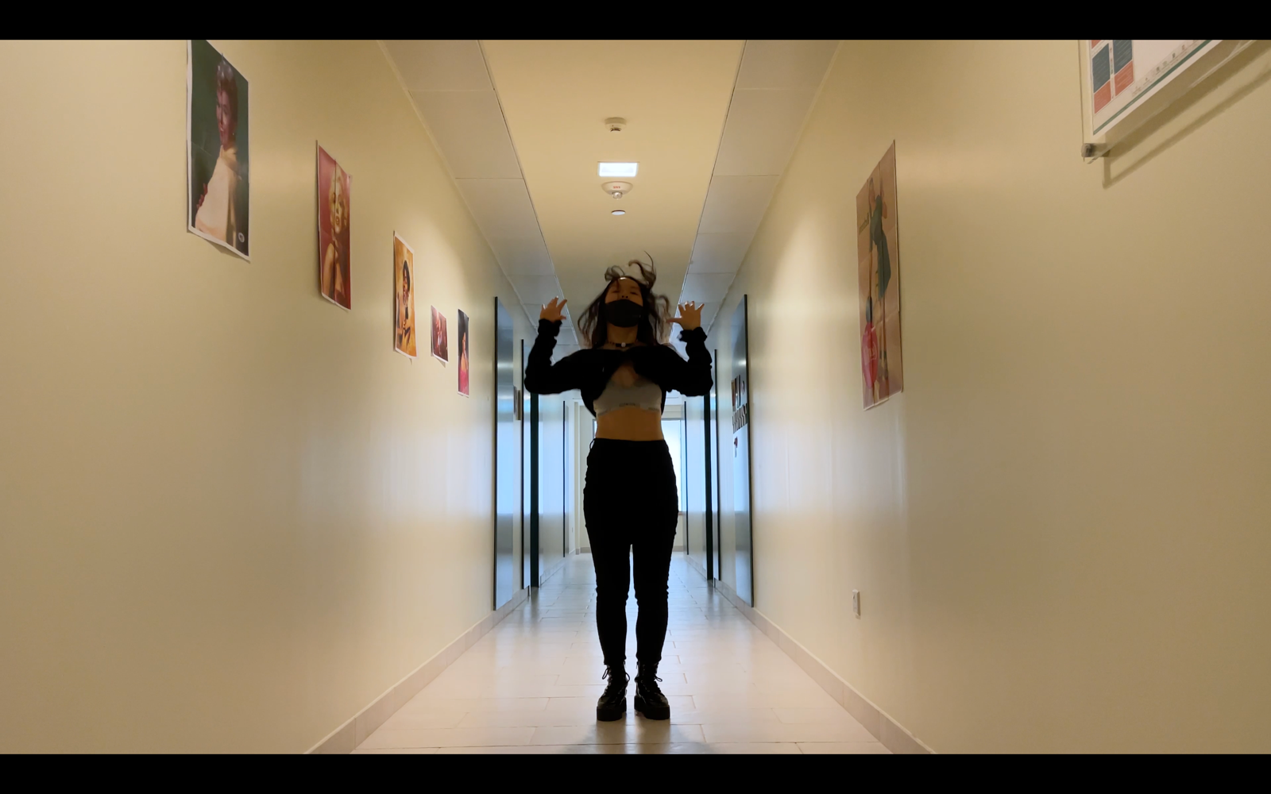

POSE 14 00:00:36:00 & 00:00:43:18

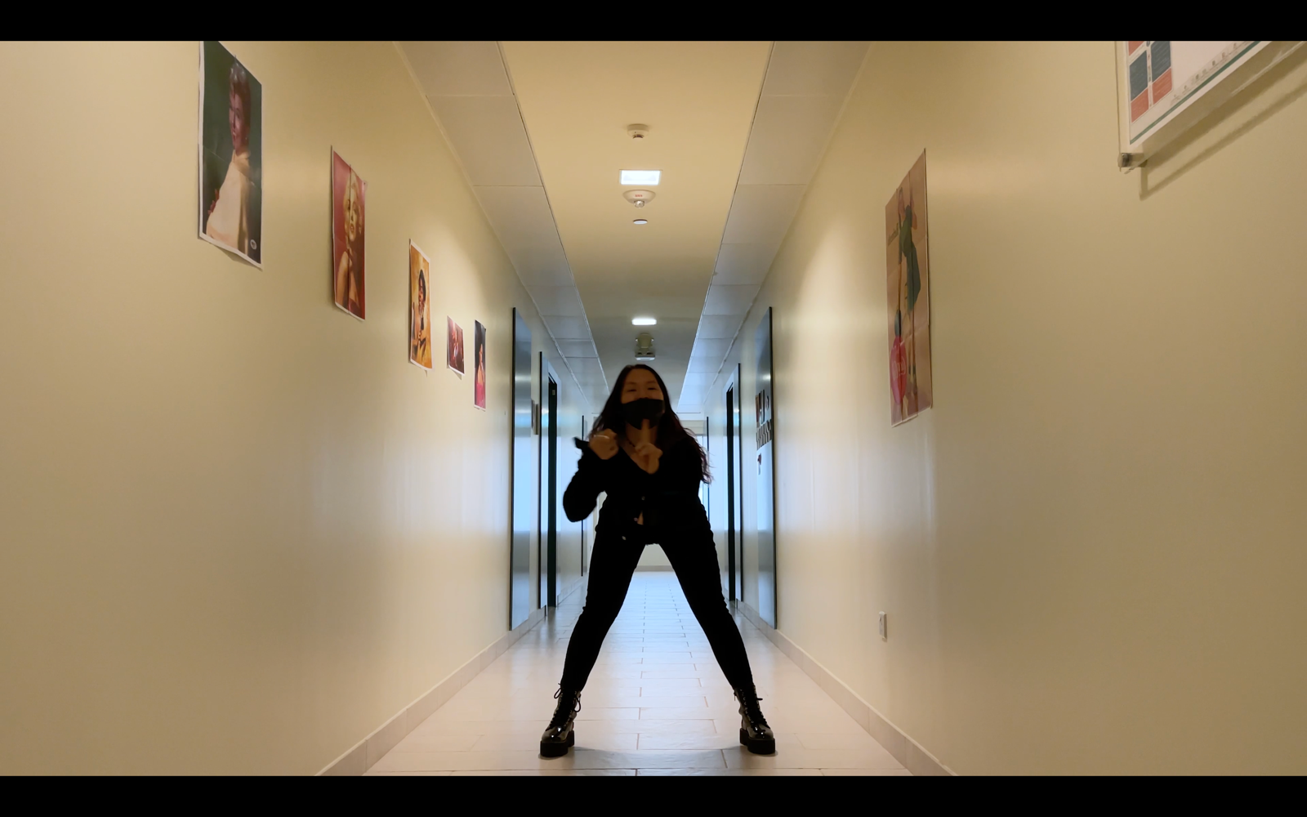

POSE 15 00:00:37:02

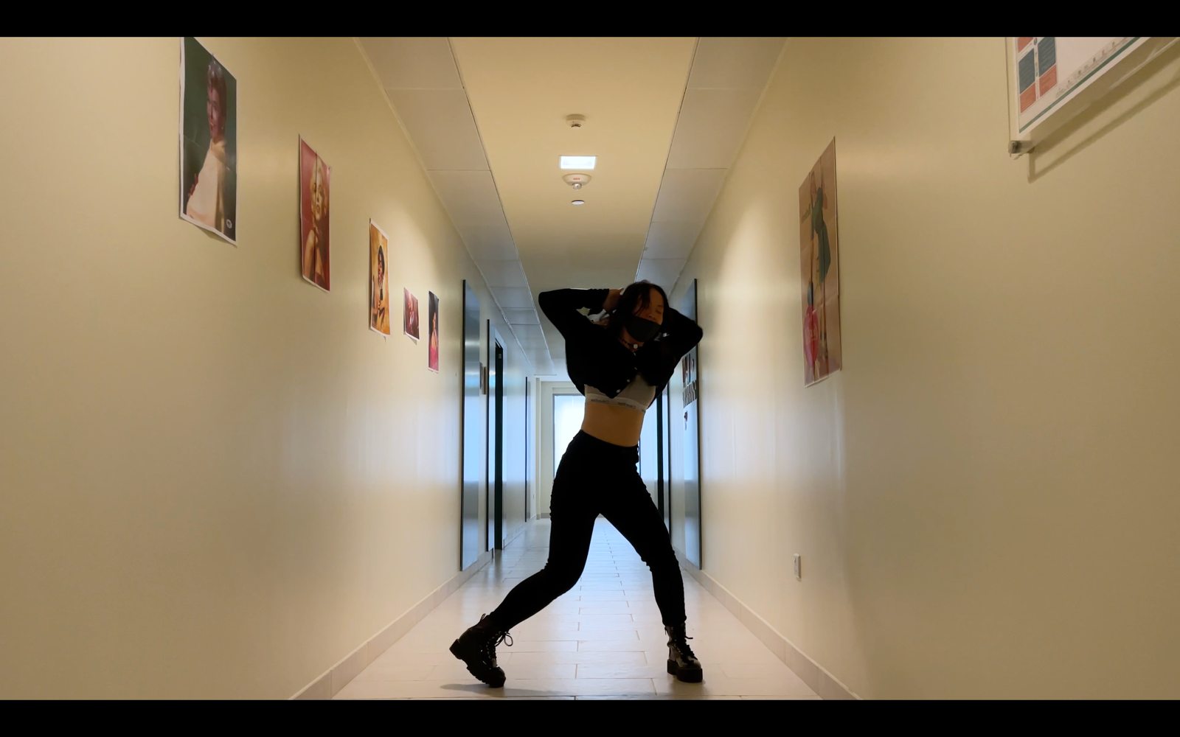

POSE 16 00:00:39:23

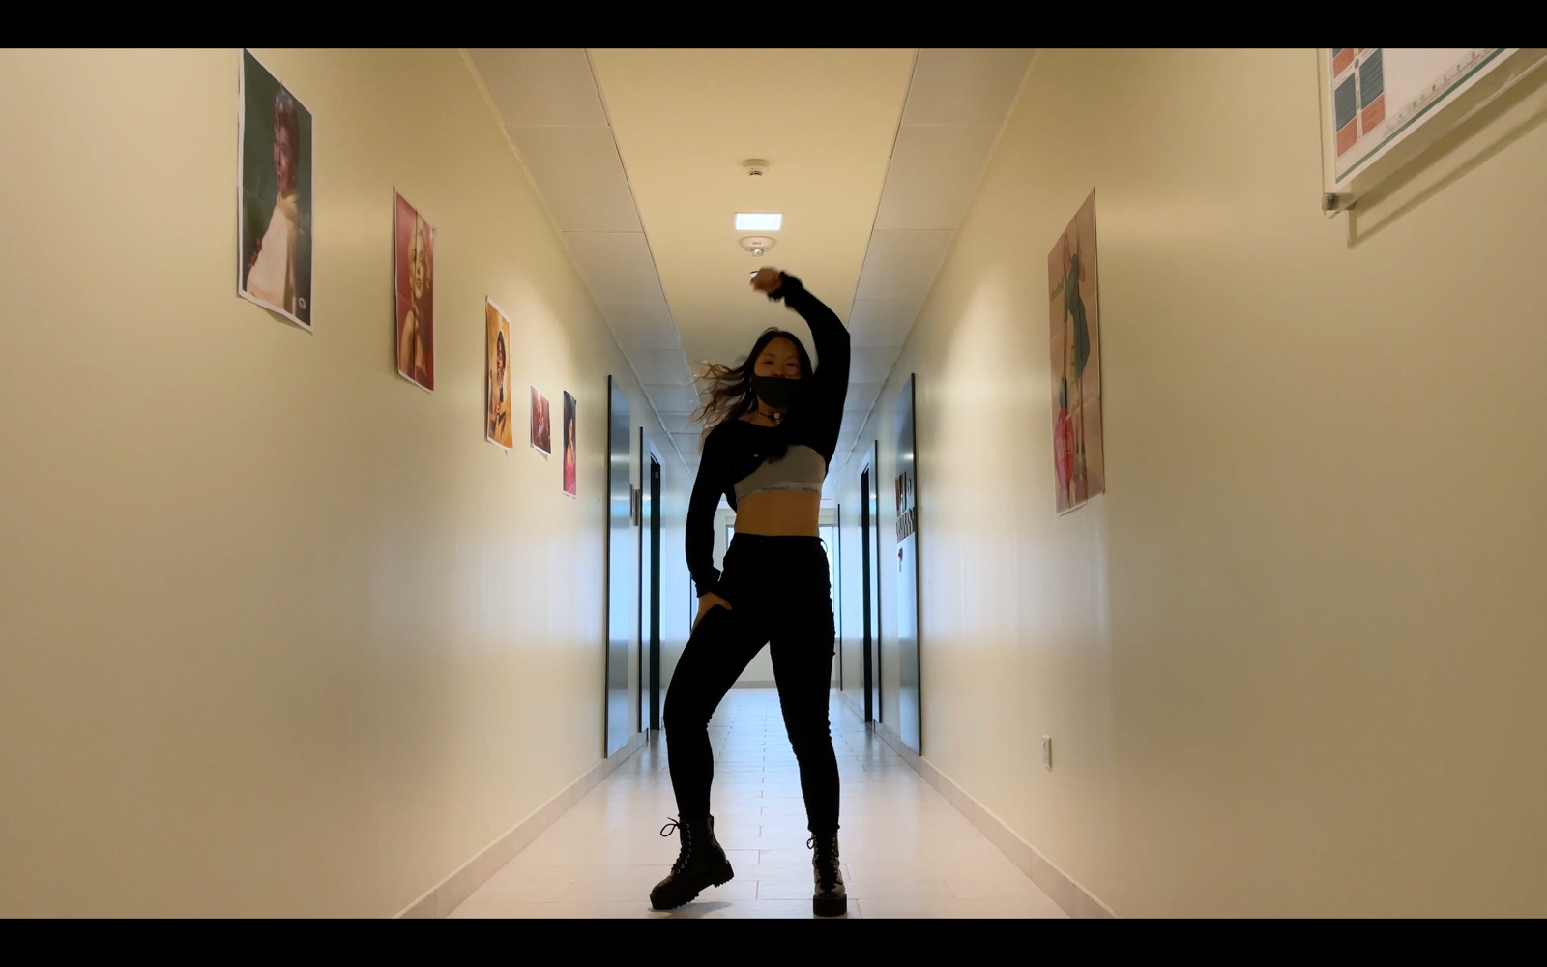

POSE 17 00:00:41:26

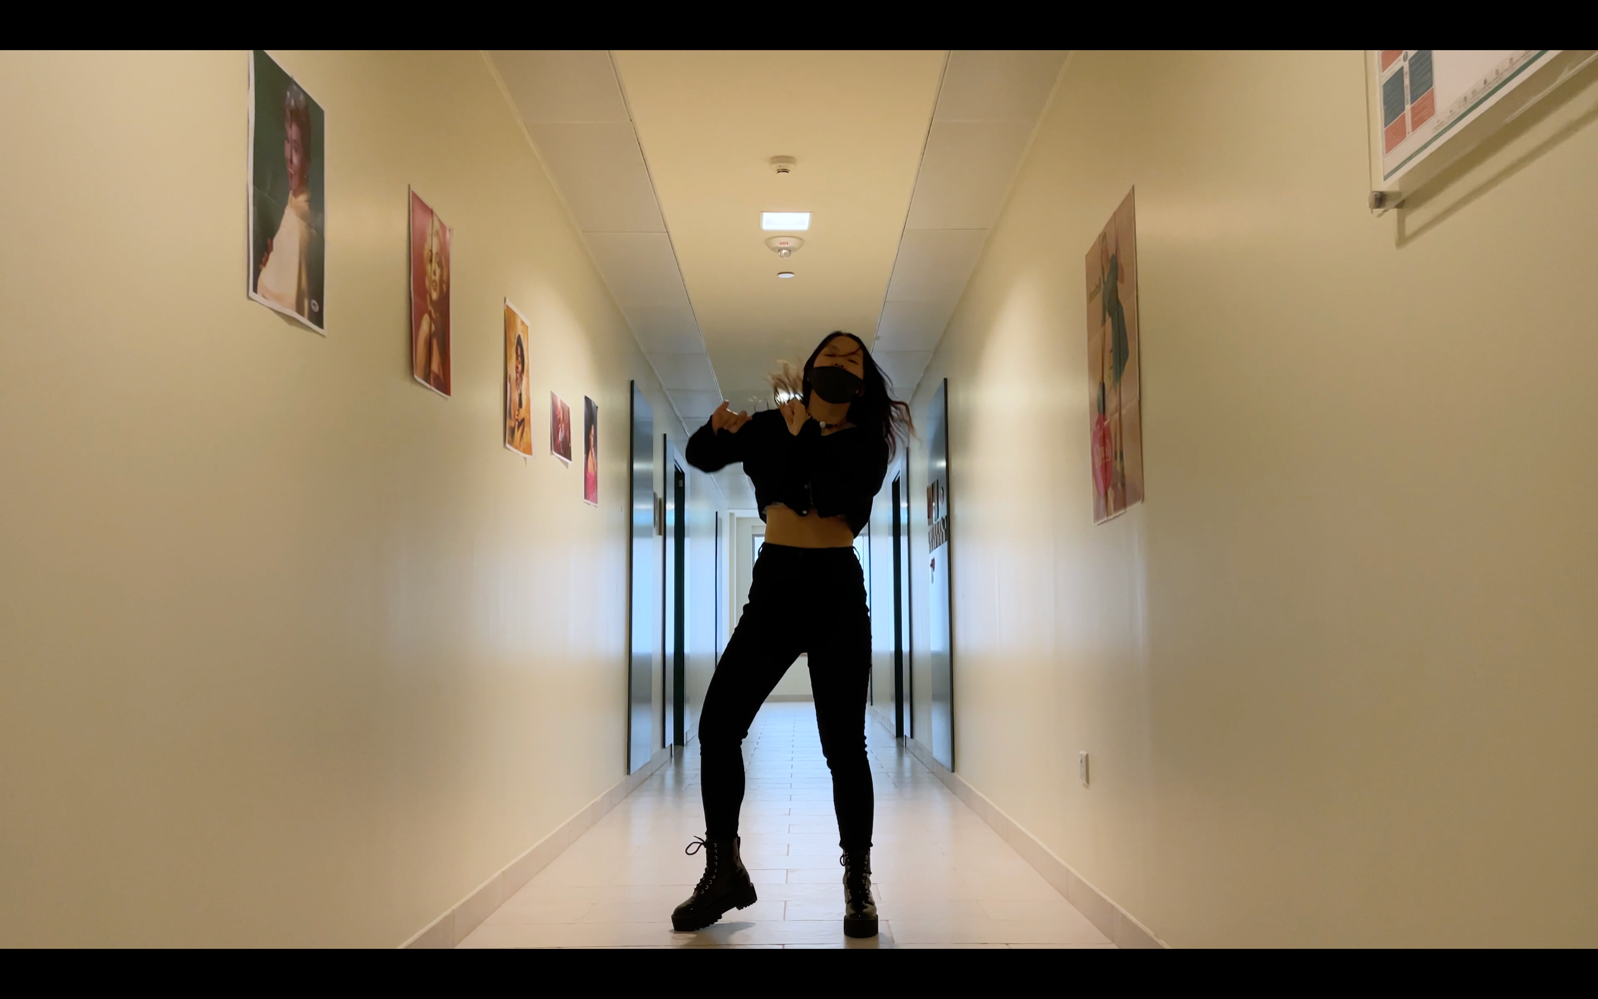

POSE 18 00:00:45:11

